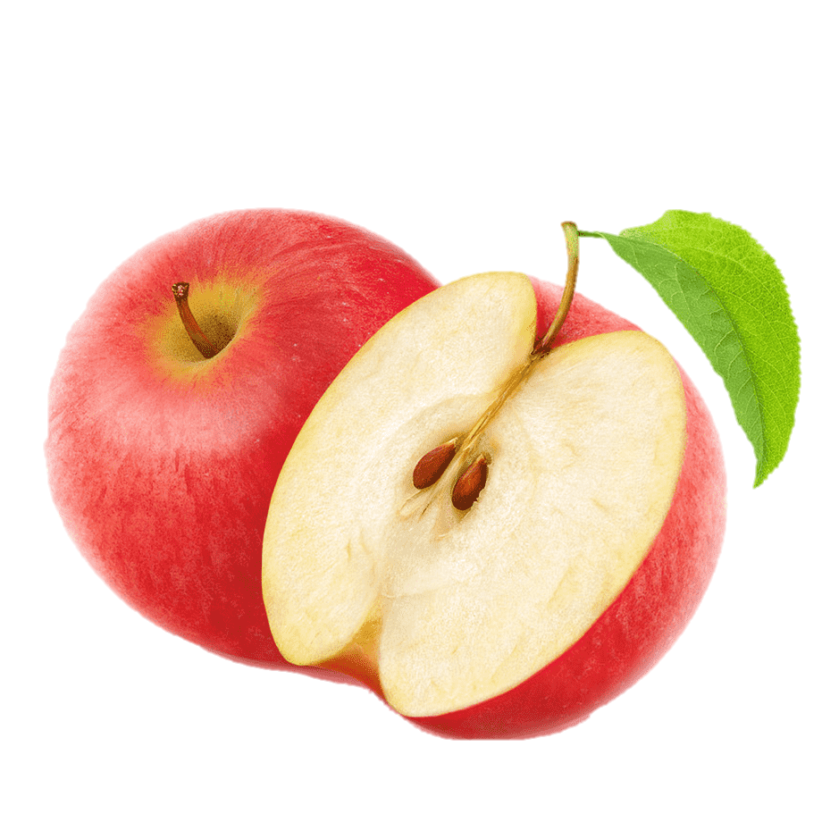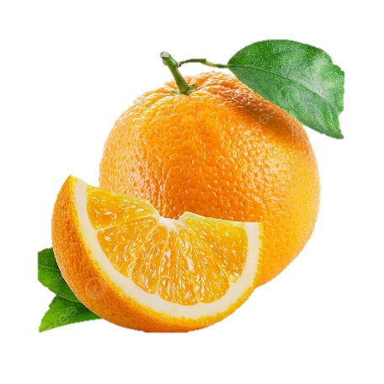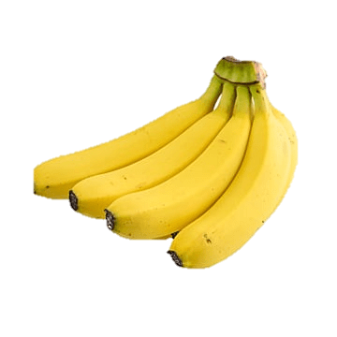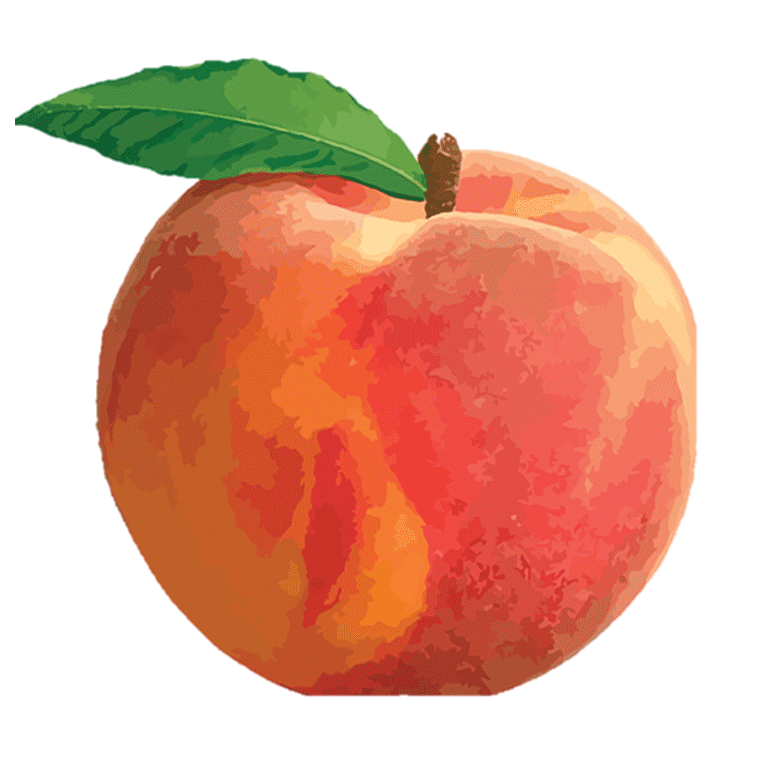

1.)

_____________________

2.)

_____________________

3.)

_____________________

4.)

_____________________

***Muhammad Uzair***